|  |  |  |
| --- | --- | --- |
| **Name: Adithya M** | **SRN: PES1UG20CS621** | **Section: K** |
| **Date: 17/1/2022** | **Lab No: 1** |

1)

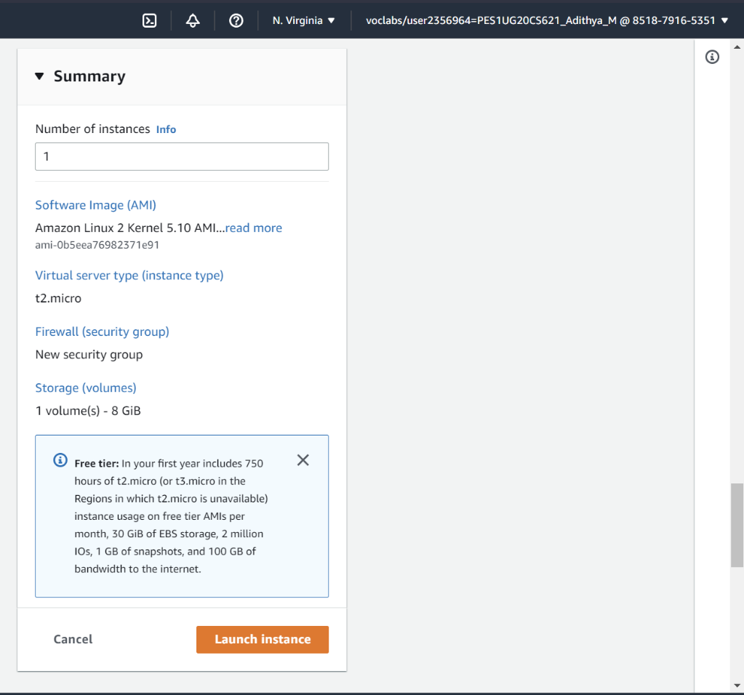

2)

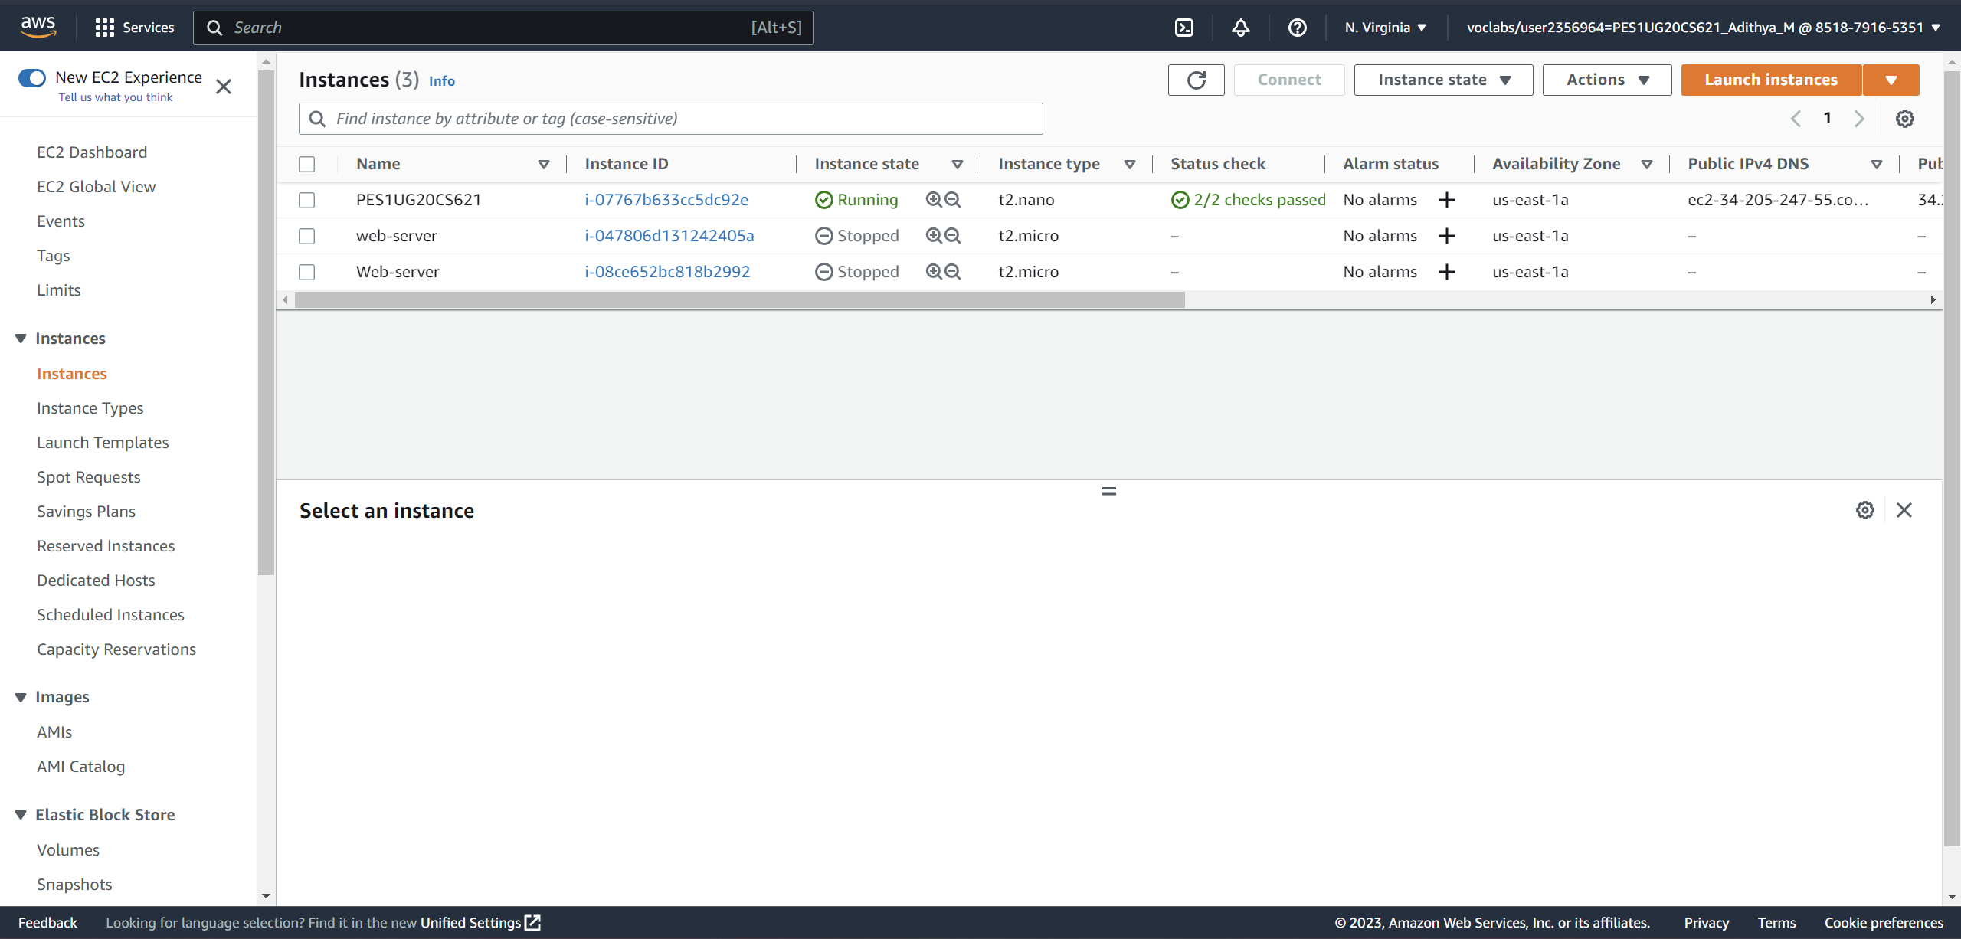

3)

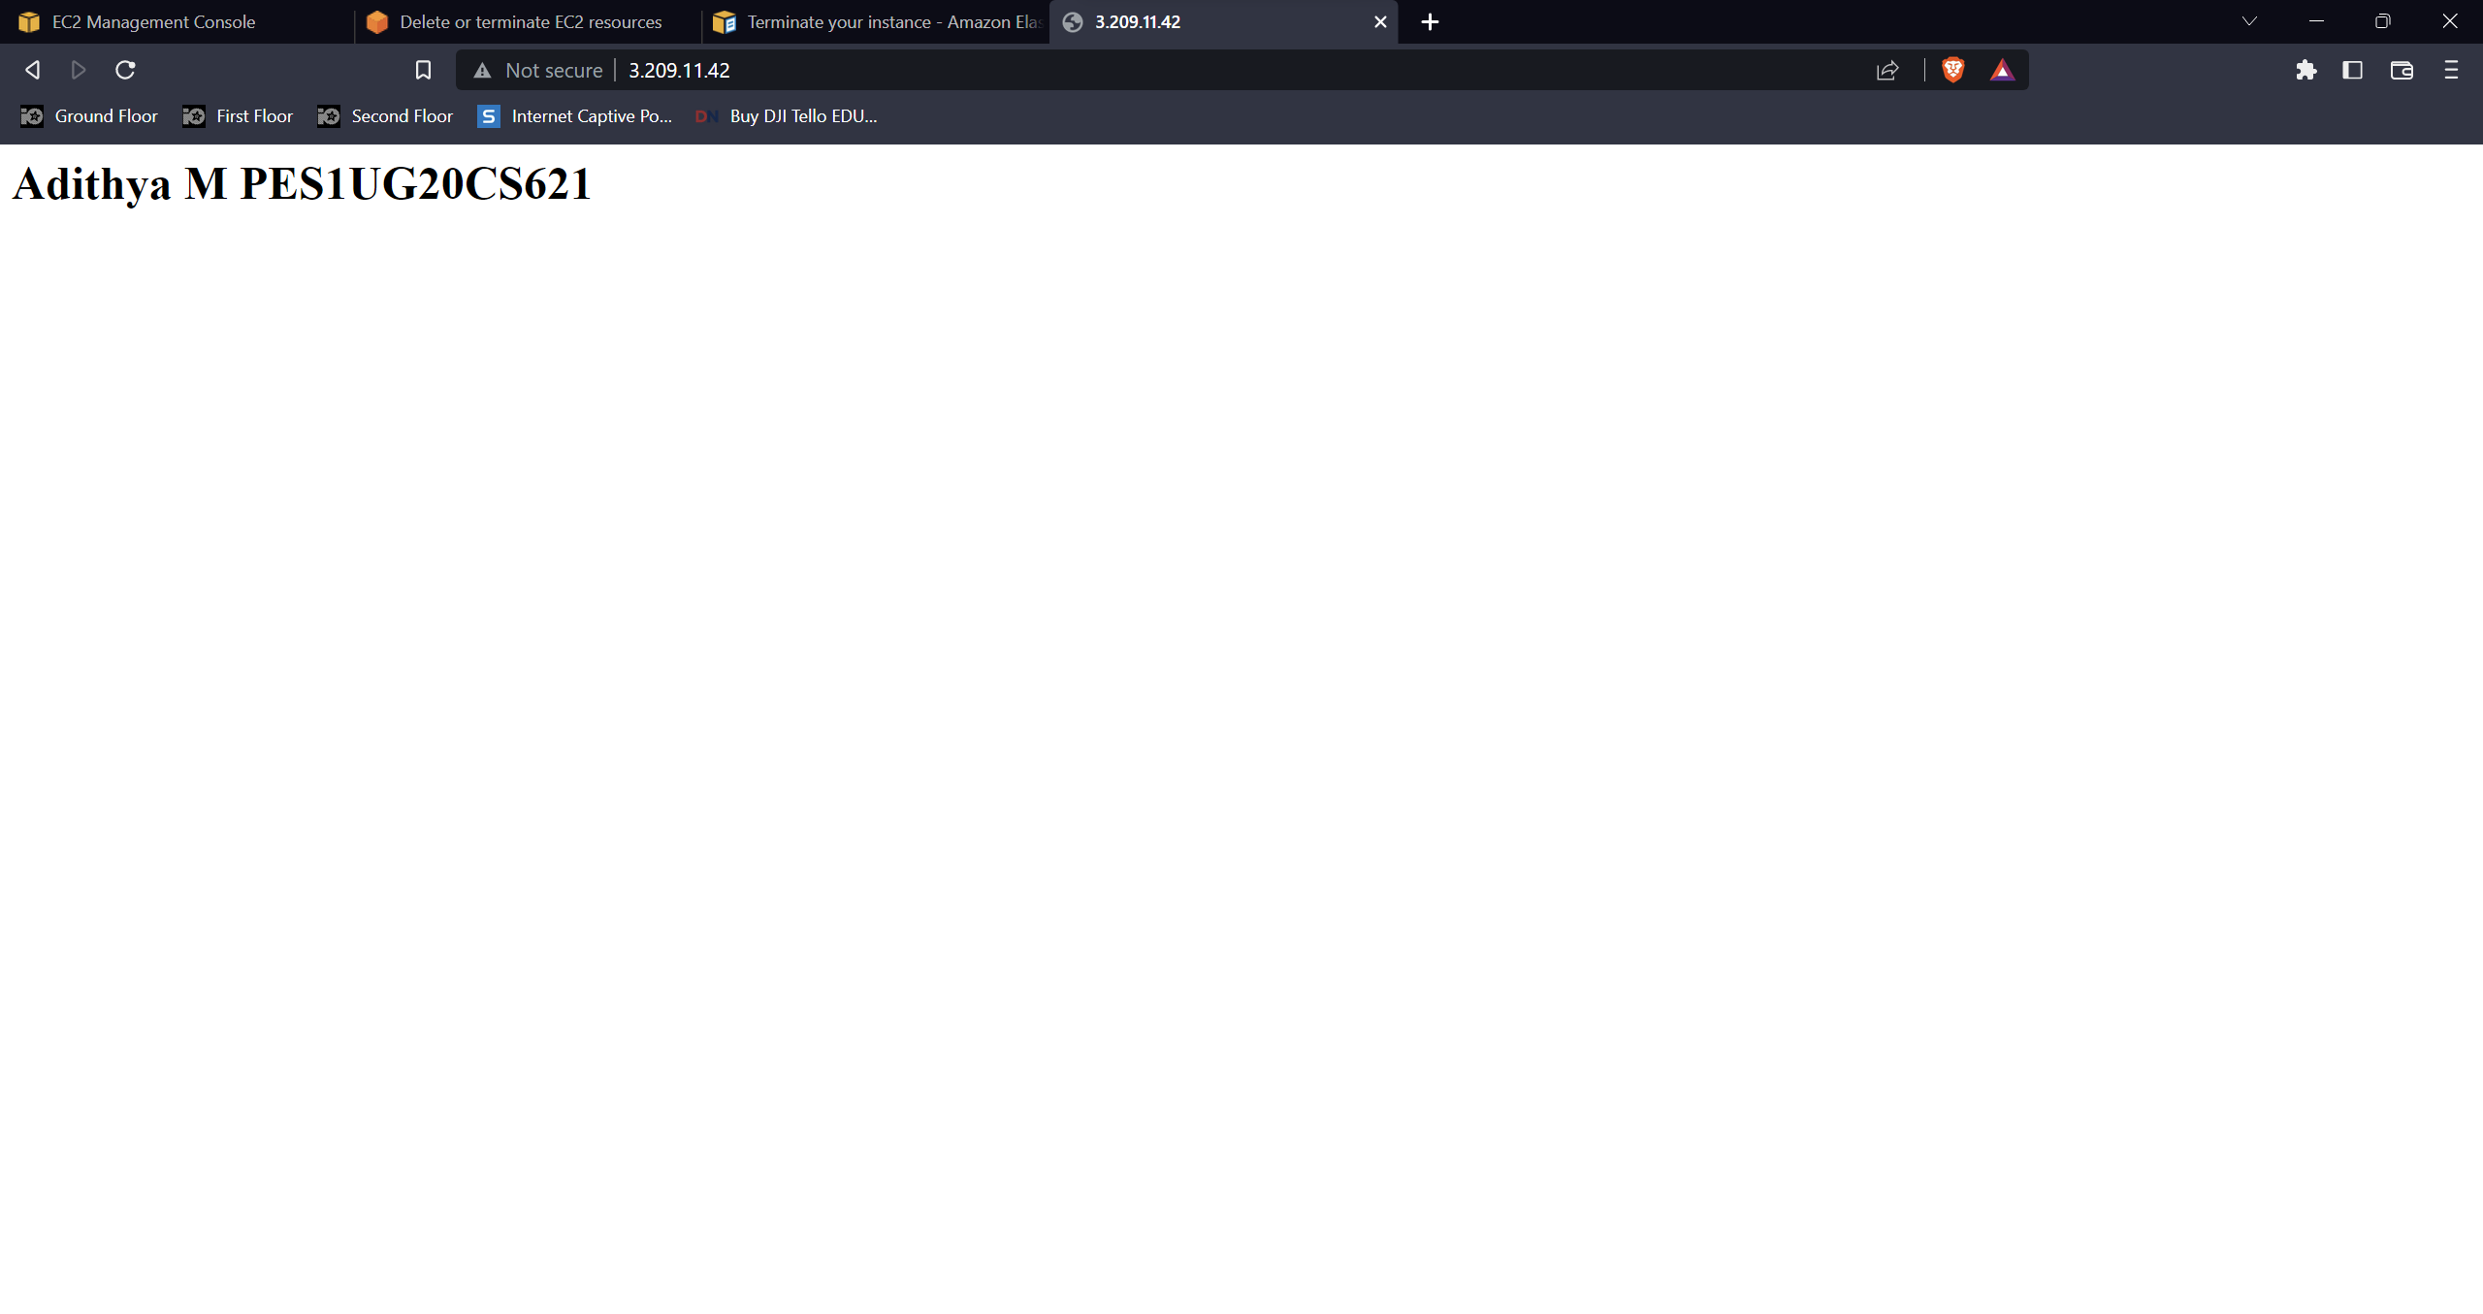

4)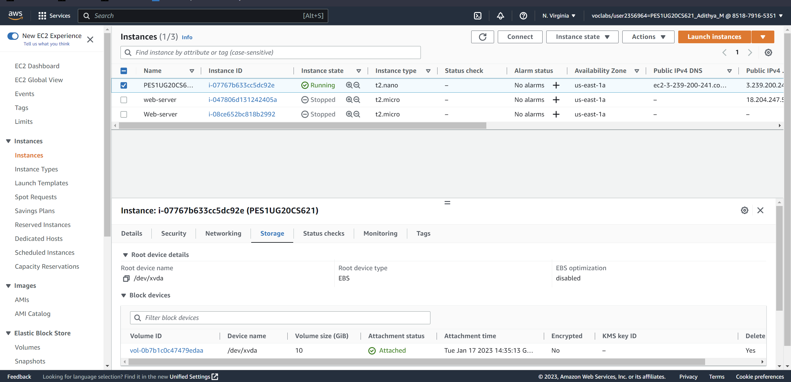

5)